Linux

1. **Open Source**
   1. **Linux Evolution And popular Operating Systems**
2. **Linux in the Cloud**

**The cloud :**

Software’s and services that run and are available on the internet

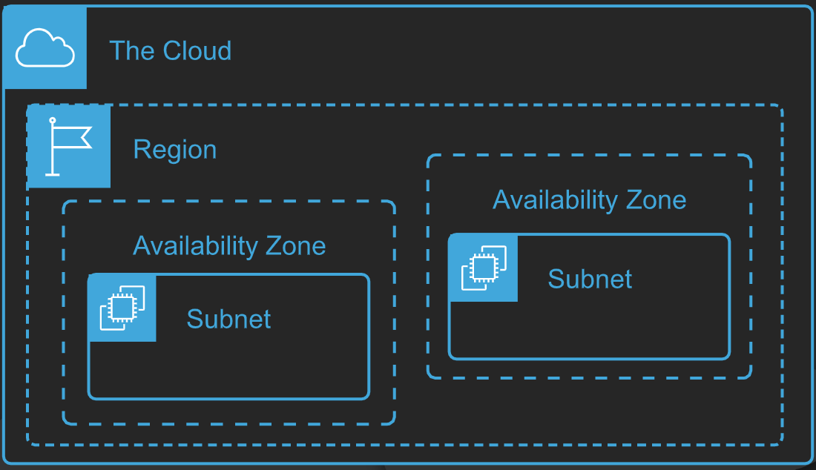

Red Question mark

**What is cloud ?**

Put simply, the cloud is collection of data centre’s providing compute, application, and storage services over internet.

